Injury Wellness Center
208- 5401 Temple Dr. N.E., Calgary, Alberta, T1Y-3R7, Canada
Phone: 587-500-1202, Fax: 403-454-3129, info@injurywellnesscenter.ca

CONFIDENTIAL PATIENT INFORMATION SHEET
PERSONAL HISTORY
Name: First__________________________Last_____________________________Date of birth:___/___/___(MM/DD/YY)

Address:___________________________________________ City:__________________ Postal code:_______________

Tel:______________________ Home____________________ Cell___________________ Business________________

E-mail:_____________________________________________________________________________________________

Emergency contact (Name): ___________________________ Relationship ____________ Phone____________________

Name of Medical Doctor: ______________________ Contact (# or address):_____________________________________

How were you referred to our facility?____________________________________________________________________

Is this related to a motor vehicle accident (MVA)? Yes No

Insurance company: ____________________________________ Claim/Policy No.:_______________________________

Extended Health Insurance: No Yes If yes, please indicate the details:____________________________

Have you ever received treatment at another Physiotherapy Clinic before? No Yes

If yes, where? (Name of the Clinic)_____________________________ when? _________________________________

Working before accident? No Yes If Yes, Occupation:__________________________________________

Working after accident? No Yes If Yes, Name of company____________________________________

Are you Primary caregiver? No Yes How many children? _______ Ages?___________________________

Are you able to perform housekeeping after the accident? No Yes

ACCIDENT DETAILS

Where you a: Driver Passenger Pedestrian Other_______________________________

Date of Accident (MM/DD/YY): ______/_______/________ What time did the accident occur? _______:_________(a.m./p.m.)

Give a brief description of the accident and what happened to you._____________________________________________
__________________________________________________________________________________________________
__________________________________________________________________________________________________
__________________________________________________________________________________________________
__________________________________________________________________________________________________
__________________________________________________________________________________________________

Reason for traveling (e.g. going to work, visiting family etc.)___________________________________________________

Who was in the car with you? (Passengers, if applicable)_____________________________________________________

Car driven at the time of the accident? (ride off/fixed)________________________________________________________

Where you a seat-belted driver/passenger? Yes No

Where did the accident occur? (Please be specific: address, street, intersection, city, and province)
__________________________________________________________________________________________________

How was the weather that day?_________________________________________________________________________

Impact of your vehicle (rear-ended, front, side)_____________________________________________________________

Did your airbags deploy? No Yes

Immediately after the impact, what are your injuries? (please describe)__________________________________________
__________________________________________________________________________________________________
__________________________________________________________________________________________________

Did you lose consciousness? No Yes (how long?)_______________________

Did a police or ambulance come to the scene? No Yes

Were you brought to the hospital after? No Yes

Did you have an X-Ray done? No Yes

CURRENT HEALTH HISTORY
Current concern(s) and when they are started- in order of importance___________________________________________
_________________________________________________________________________________________________
________________________________________________________________________________________________

Rate your pain now (None) 1 2 3 4 5 6 7 8 9 10 (Worst)

Have you had this injury before? No Yes If yes, when?___________________________________

Have you had previous treatment? No Yes If yes, when?__________________________________

List any medications, supplements (vitamins, etc) you are currently taking:_______________________________________

List any medical conditions you have been diagnosed with (e.g. diabetes, heart disease, cancer, etc.)__________________

Do you wear orthotics? No Yes If yes, how long have you had them?_________________________

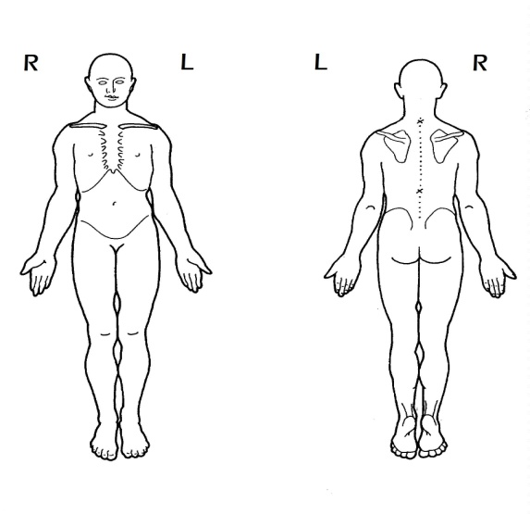
How much sleep do you get per night?___________________________________________________________________

Comments_____________________________________________
______________________________________________________
______________________________________________________
______________________________________________________
______________________________________________________
______________________________________________________
______________________________________________________
______________________________________________________

HEAD TO TOE CHECKLIST | YES | COMMENTS
HEAD AND FACE
Head bumps or bruise
Headache
Blurry Vision
Bruise on the face
Do you have pain in your forehead?
Do you have pain at the back of your head?
Hearing problems
Jaw pain/tenderness
Clicks on the jaw when talking or chewing Left or Right?
NECK
Bruise on the neck Left or Right?
Pain and Tenderness Left or Right?
Clicks on the neck when turning side to side
SHOULDER
Bruise on the shoulder Left or Right?
Pain and Tenderness Left or Right?
UPPER EXTREMITIES
Bruise on the arms Left or Right?
Pain and Tenderness on arms Left or Right?
Numbness on arms Left or Right?
Bruise/Fractures on the elbow Left or Right?
Pain on elbow when bending and extending? Left or Right?
Bruise on the wrist Left or Right?
Numbness on the forearm Left or Right?
Hand pain?
Hand numbness Left or Right?
CHEST
Bruise on the Chest
Pain on the Chest
Difficulty in Breathing
ABDOMINALS
Pain and Tenderness
Upper left Upper right Lower left Lower right
BACK
Bruise in the back
Pain and Tenderness High Mid Low?
LOWER EXTREMITIES
Bruise/Fracture in the hip?
Pain and Tenderness in the hip
Pain when sitting
Bruise on the thing Left or Right?
Pain and Tenderness in the hip Left or Right?
Bruise on the knee Left or Right?
Pain and Tenderness in the knee Left or Right?
Bruise on the Leg Left or Right?
Pain and Tenderness on the leg Left or Right?
Pain and Tenderness on the ankle Left or Right?
Numbness Thing Leg Foot
Other: (any other complaints that were not asked, but you wanted us to know. E.g. sleeping problems, fear of driving, loss of appetite, etc.)________________________________________________________________________________________________________
PAST HEALTH HISTORY
List any previous Surgeries and the year(s) they occurred____________________________________________________
List any previous Fractures and the year(s) they occurred_____________________________________________________
List any previous Accident/traumas and the year(s) they occurred______________________________________________
Please check off all applicable conditions you are experiencing or have experienced:_______________________________
I have completed the form to the best of my knowledge and I agree to share this information to the clinic and the health professionals involved in my treatment, I will also notify them if any conditions change.

Client’s signature Date

